How to Add Footers to Progress Reports in Skyward

- Open Skyward (skyward.canyonsdistrict.org) and log in.

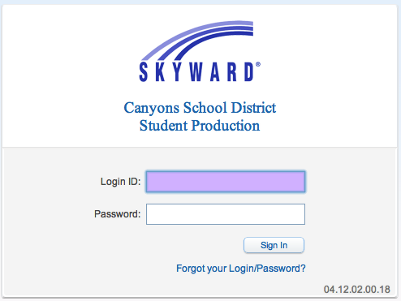
- Click the My Gradebook link.
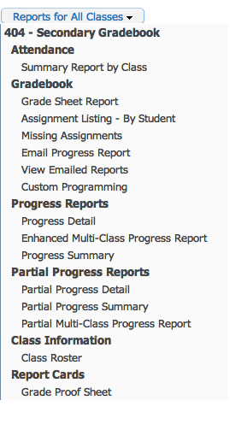

- If all of your classes are within the same content area, complete step 3a. If not, complete step 3b.
  - From the Reports for All Classes drop-down menu, select Progress Detail.
  - Click on the name of the class. From the Reports drop-down menu, select Progress Detail. Within each class, complete steps 4-8 for each content area.

- In the pop-up window, select the 900: Curr Term;No Count;Ungraded;Comments;Sig;Attn Totals report. Click Clone Template.

- In the new pop-up window, name the report MYP Progress Detail. Click Save.

- In the new pop-up window, scroll to the bottom. Type the information on the attached page regarding your content area. Scroll back ot the top. Click Save.
How to Add Footers to Progress Reports in Skyward

- Your new template will now appear in the reports list. To print or view the report as a PDF, click Print.

- The footer will now appear at the end of the report.

